**BRAC UNIVERSITY**

**Department of Computer Science & Engineering**

**Practice Problem sheet (Week5)**

**CSE 350: Digital Electronics and Pulse Technique** 

# Question 1

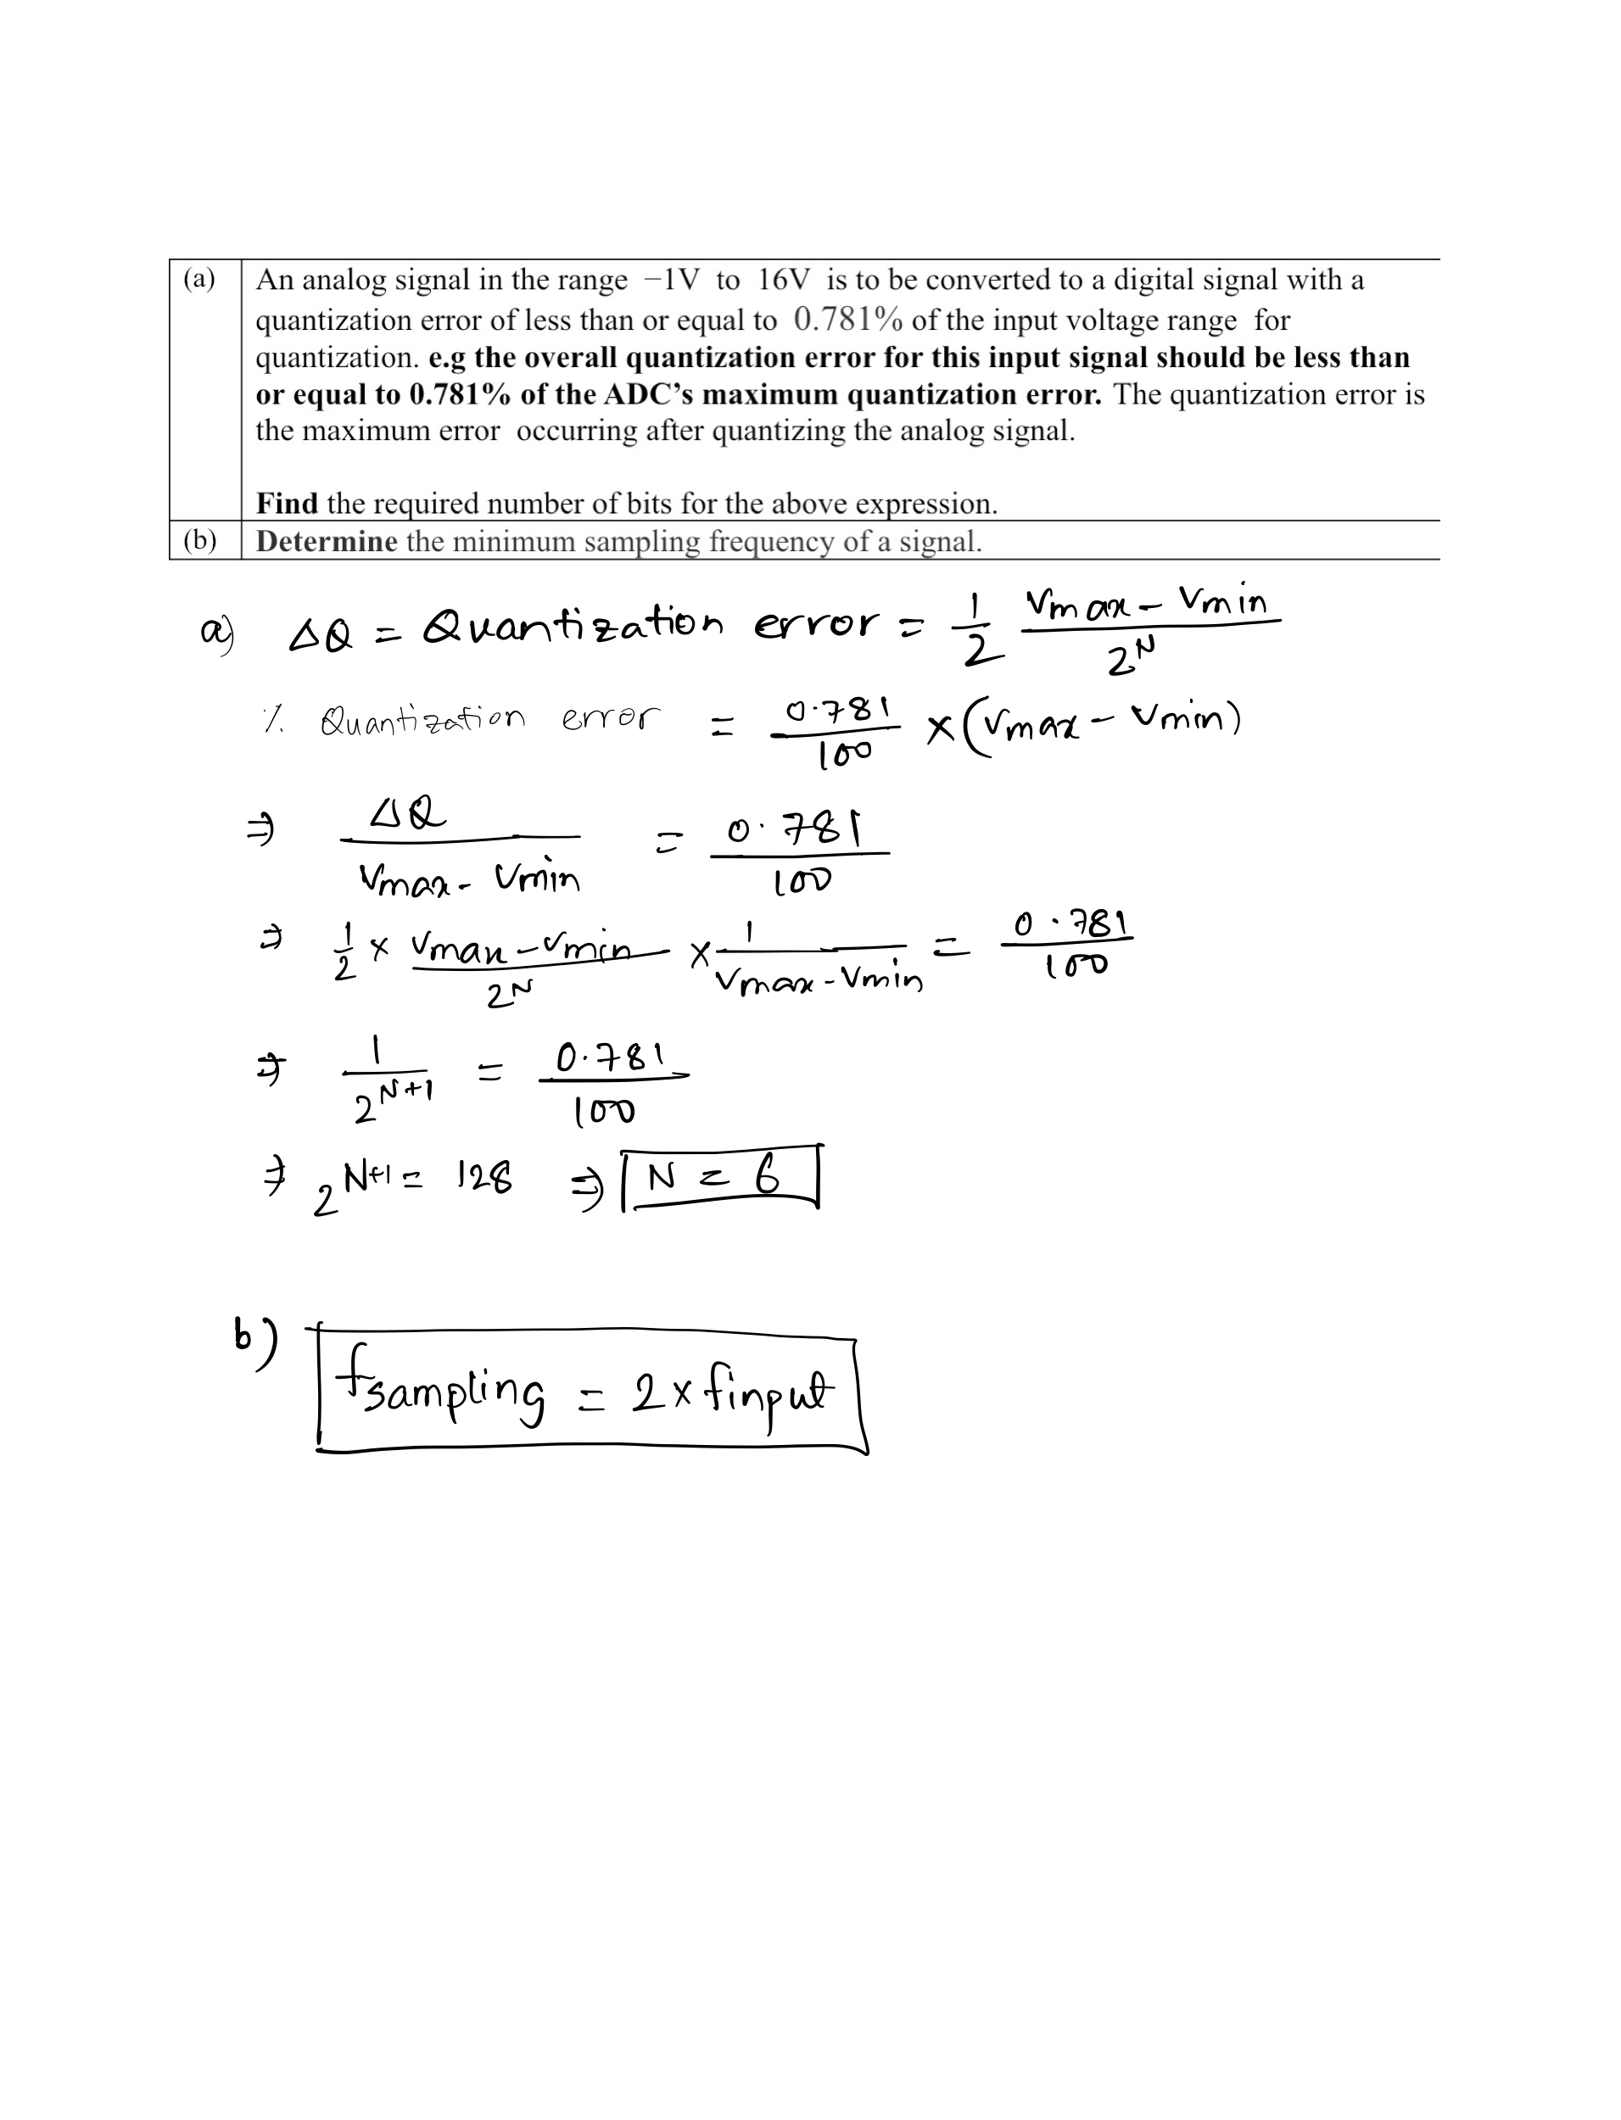

# 

# Question 2

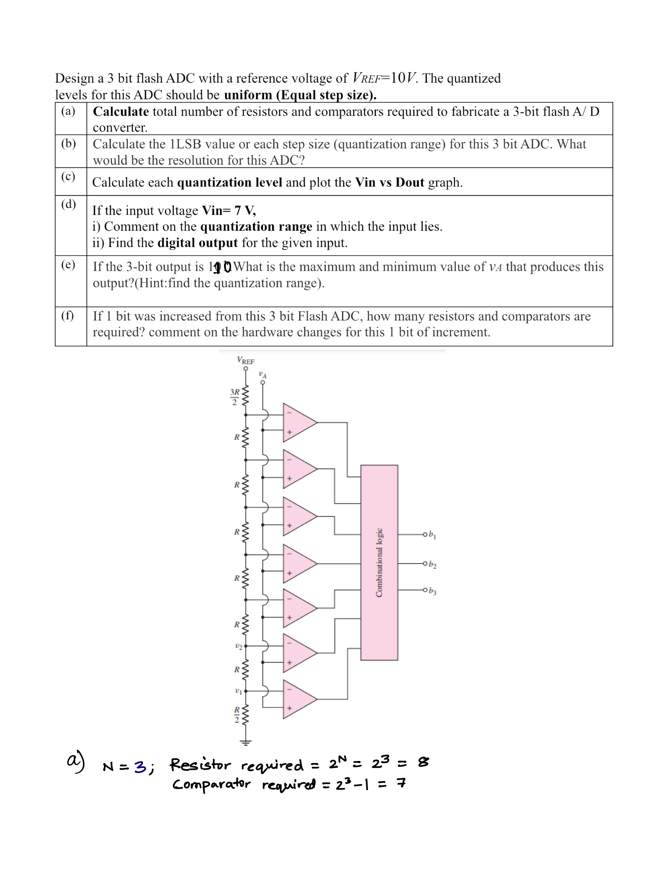

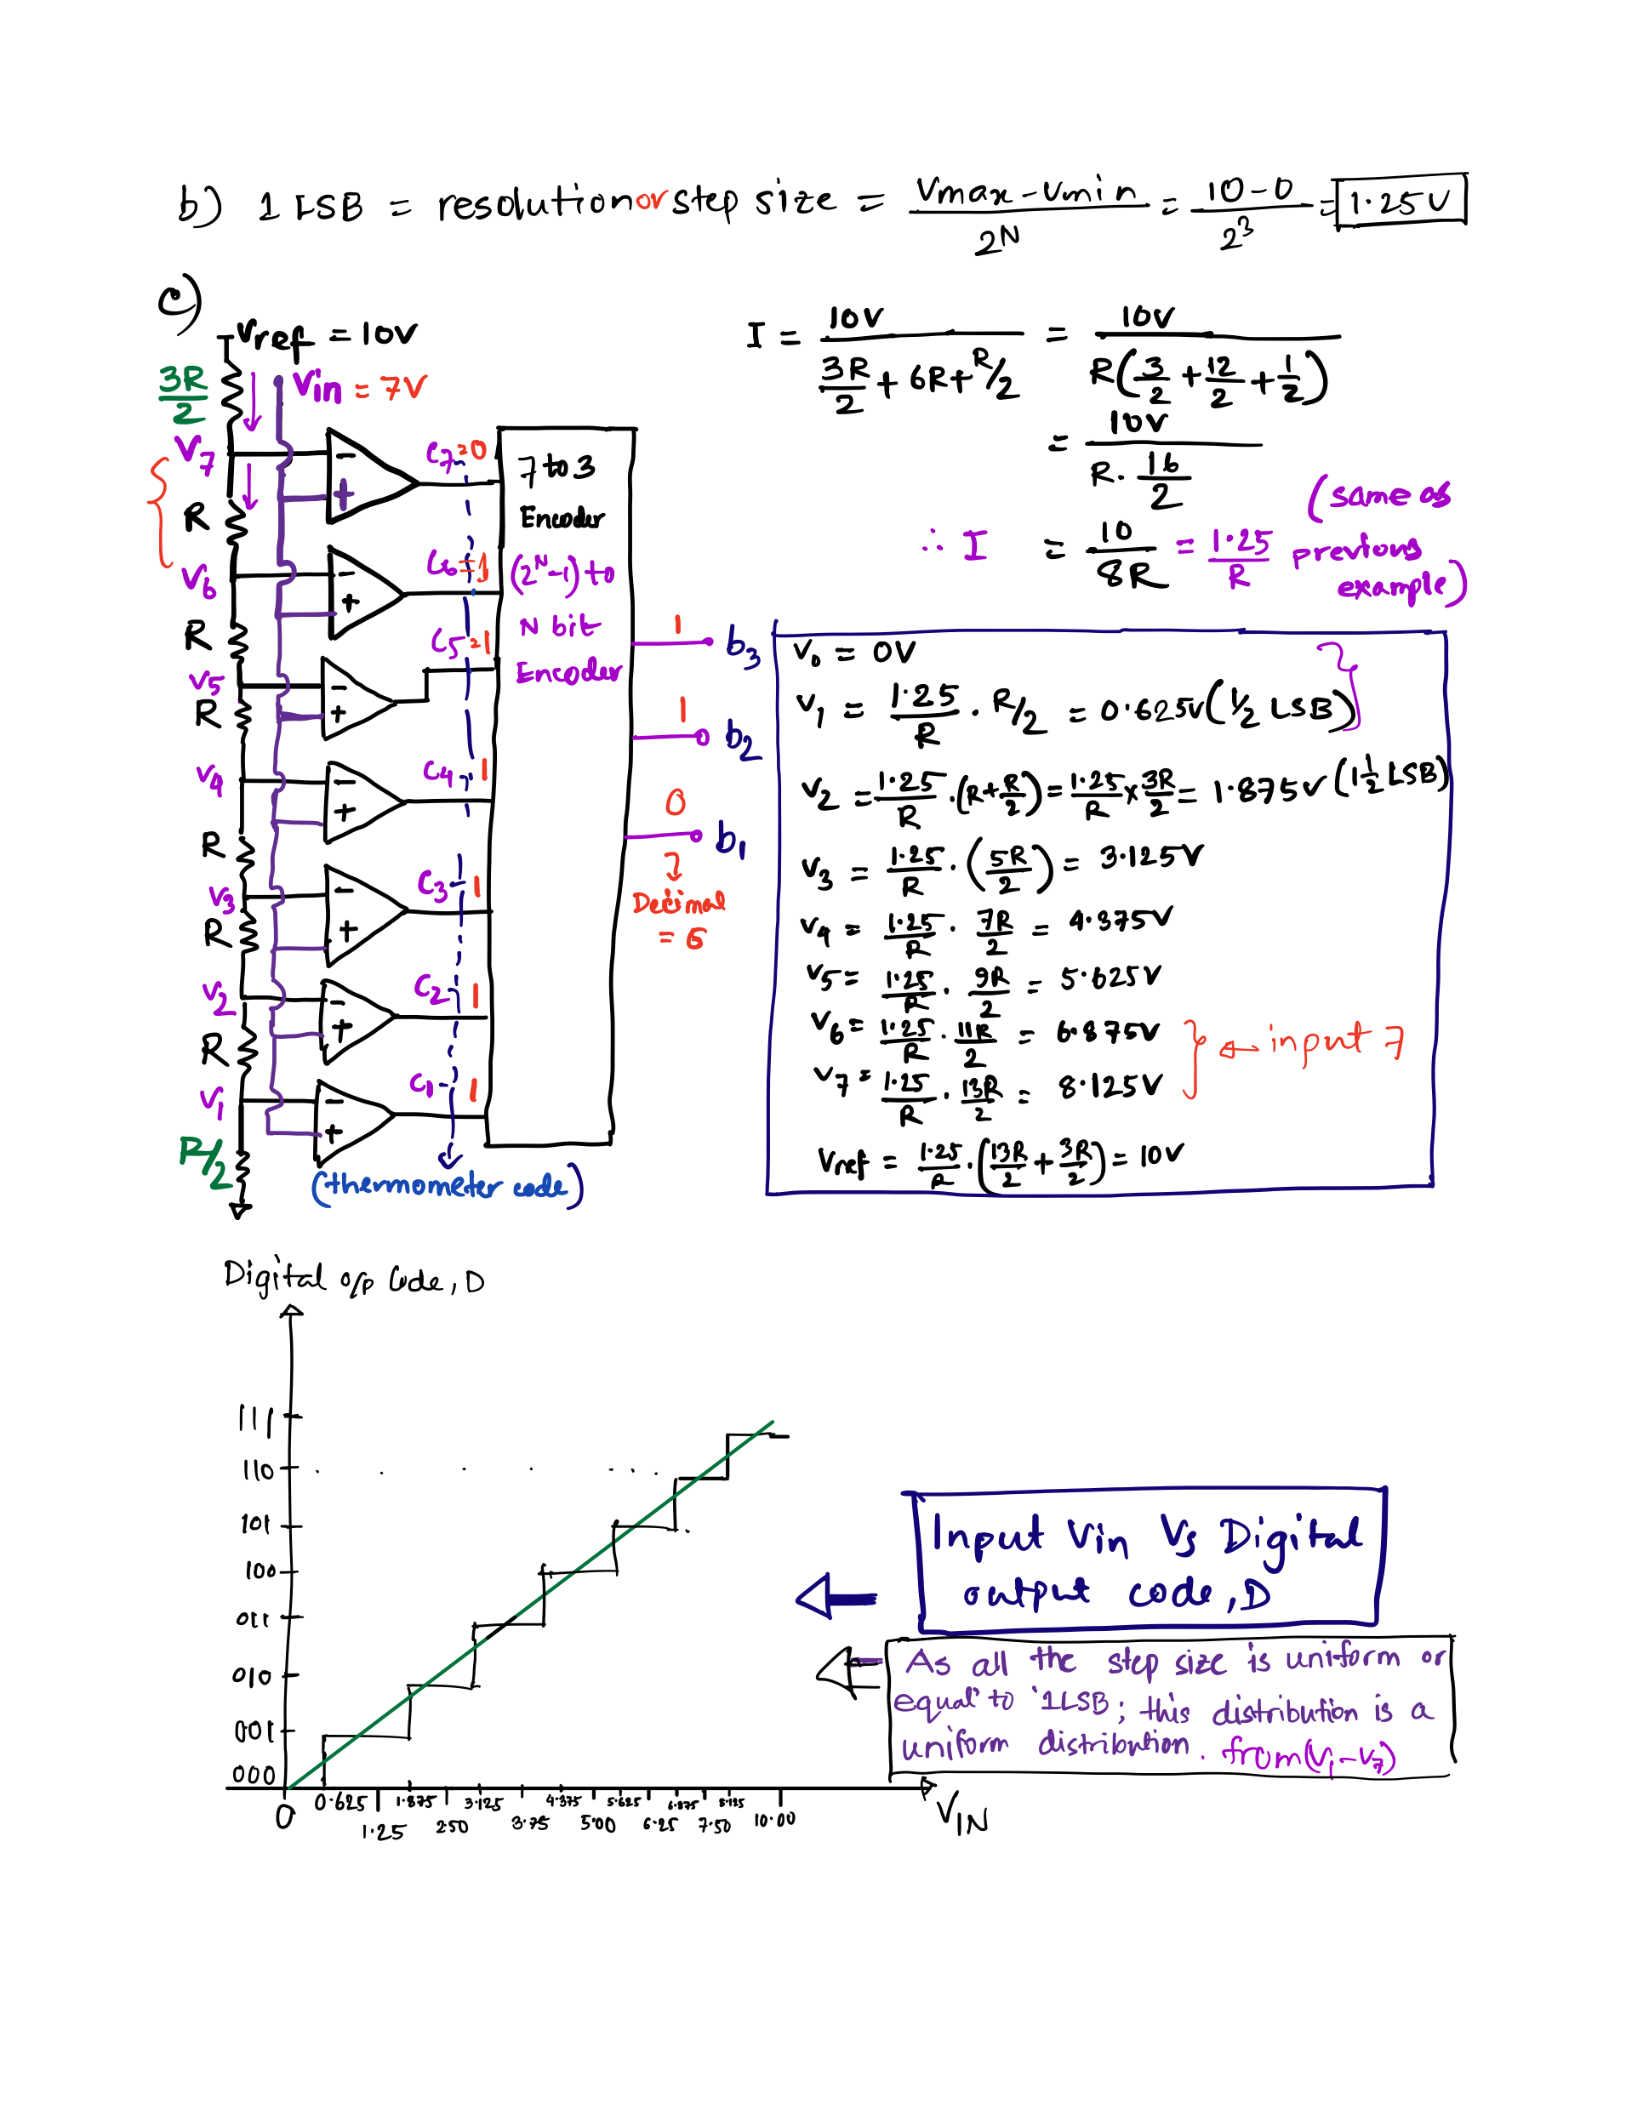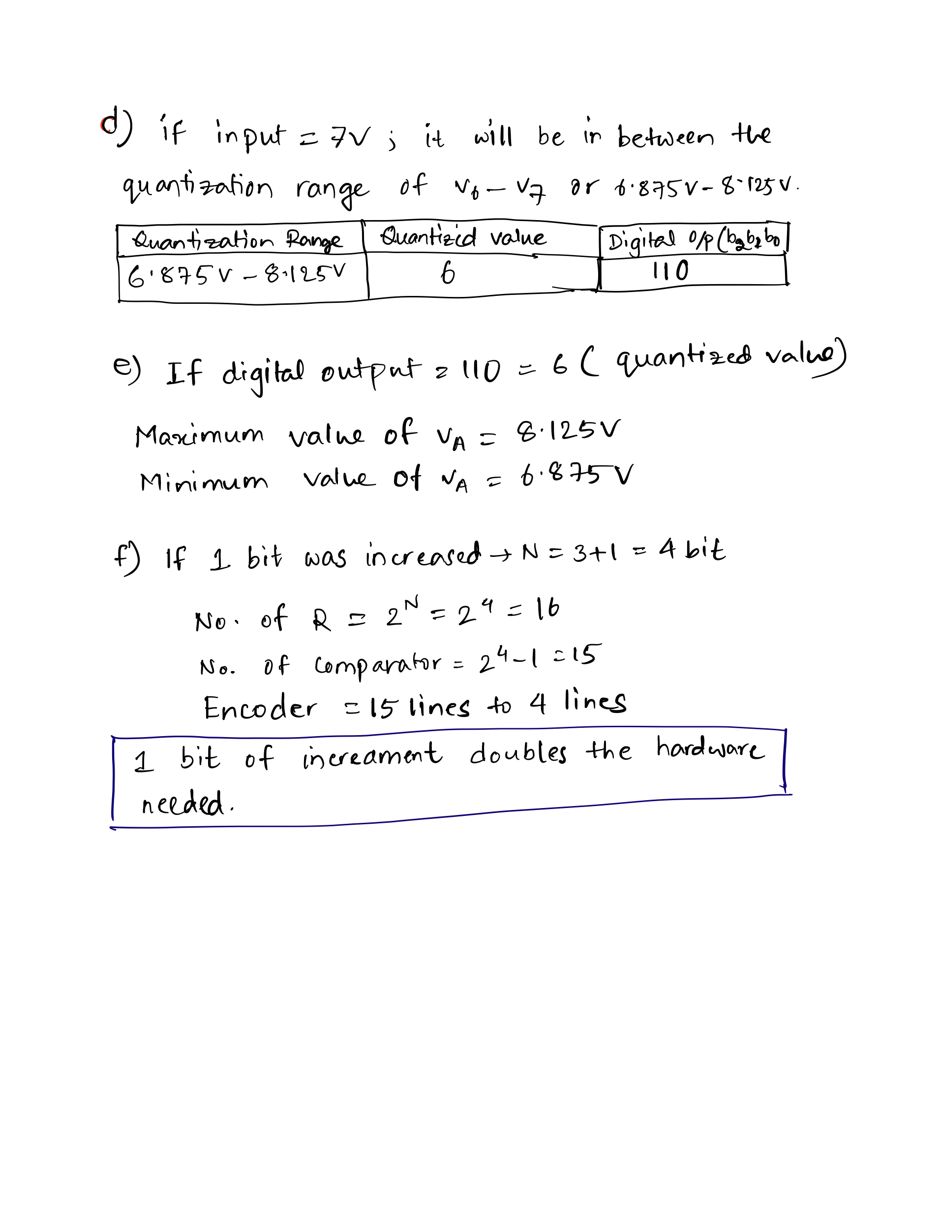

# 

# Question 3

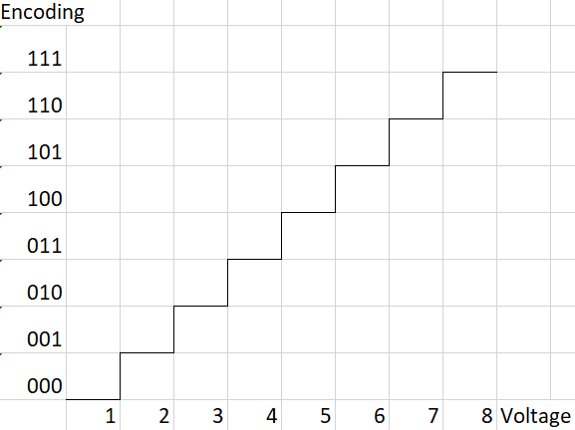

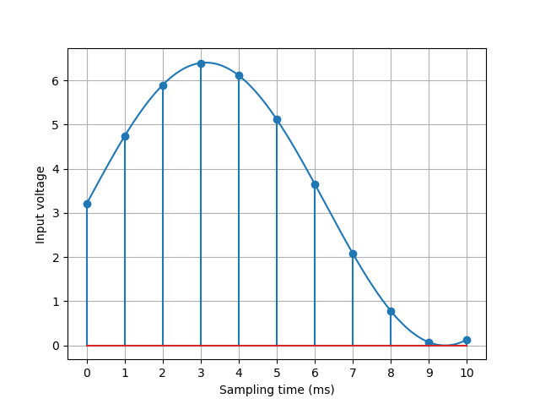

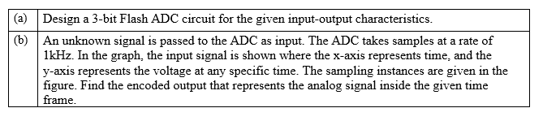

Solution:

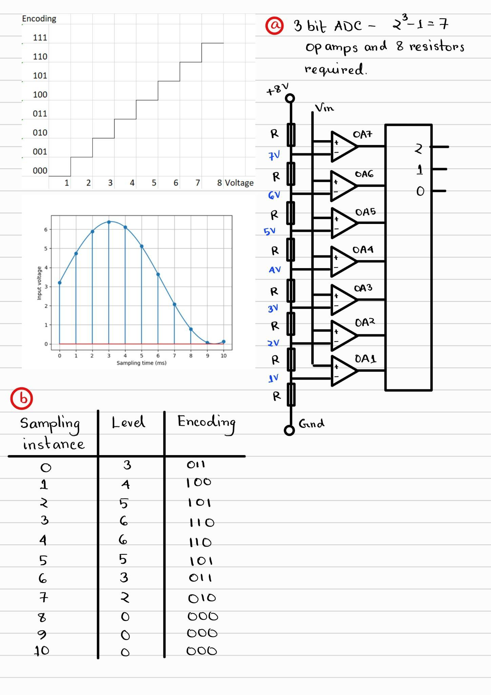

# 

# Question 4

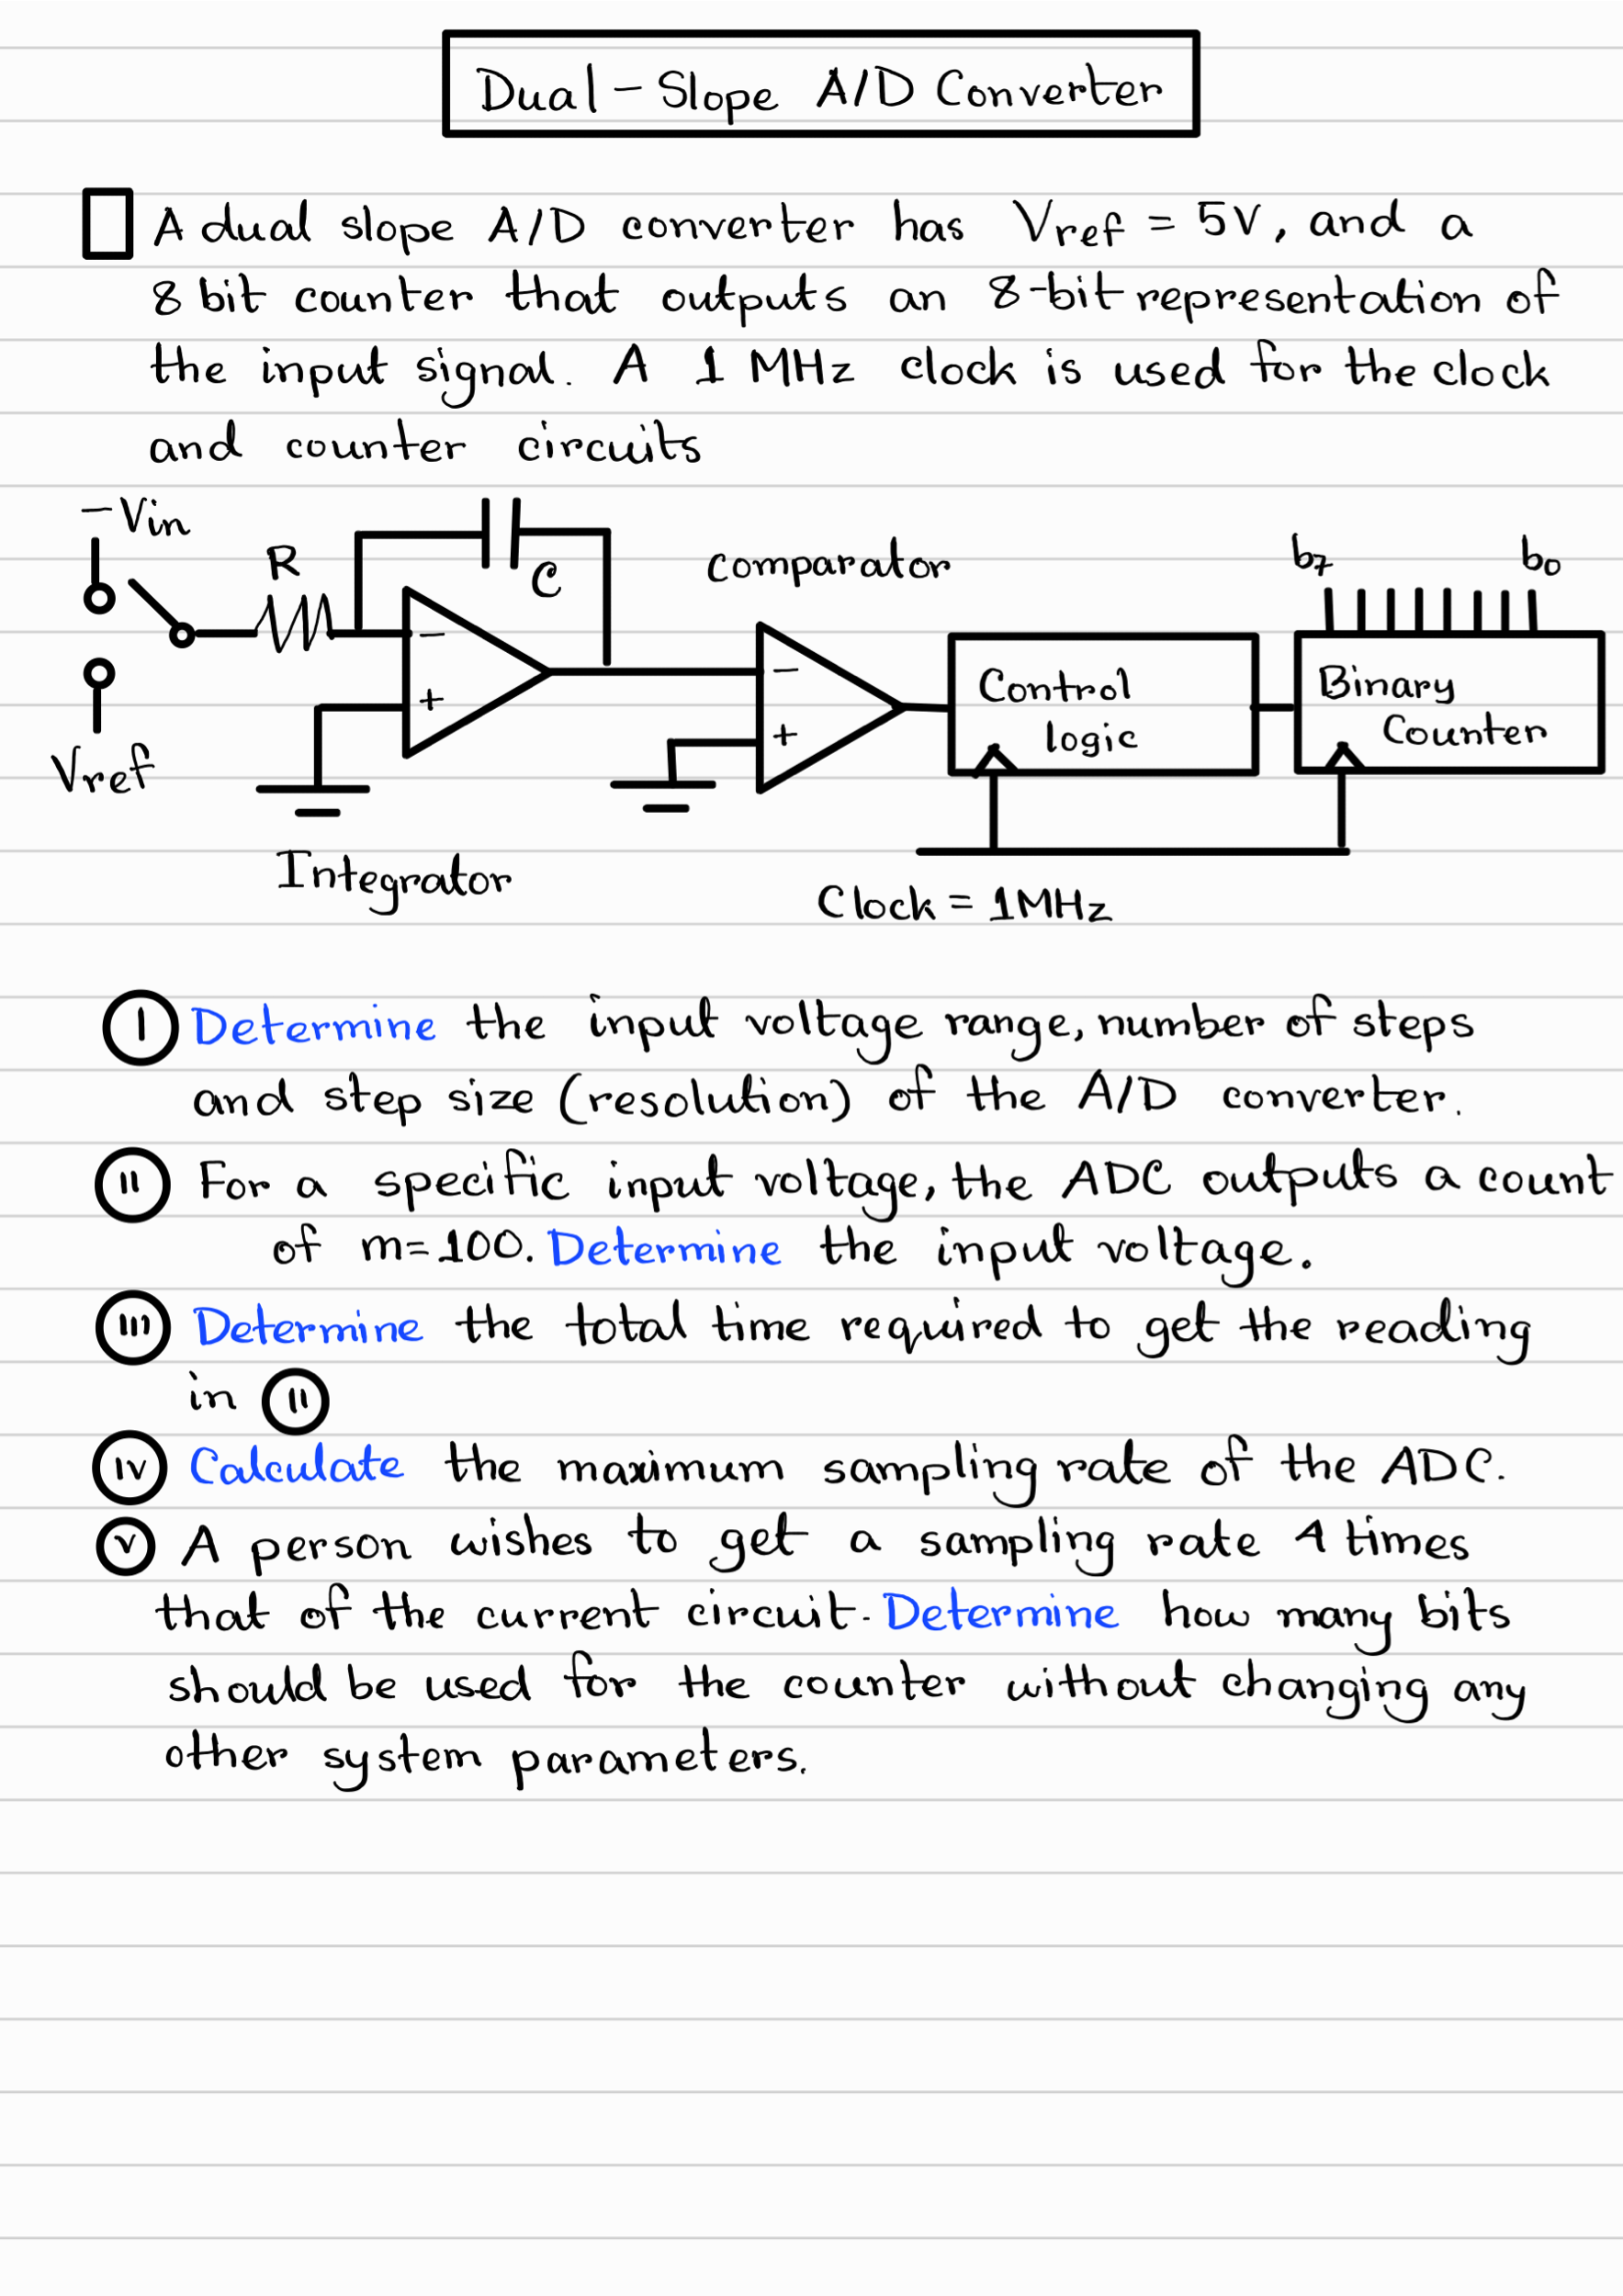

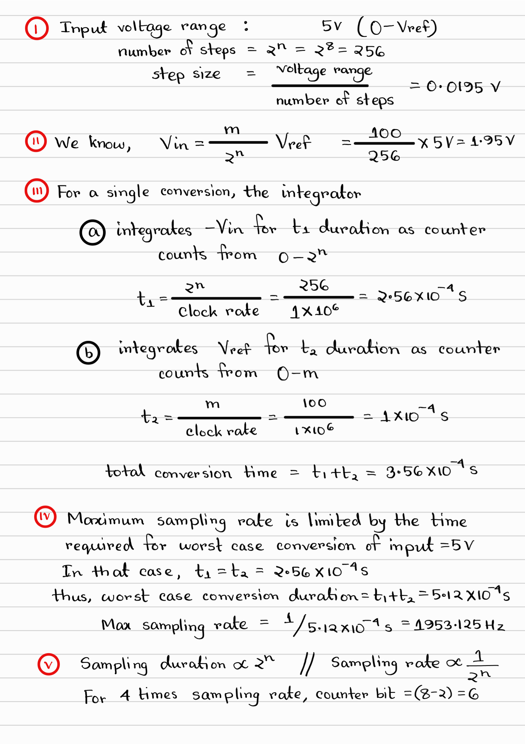

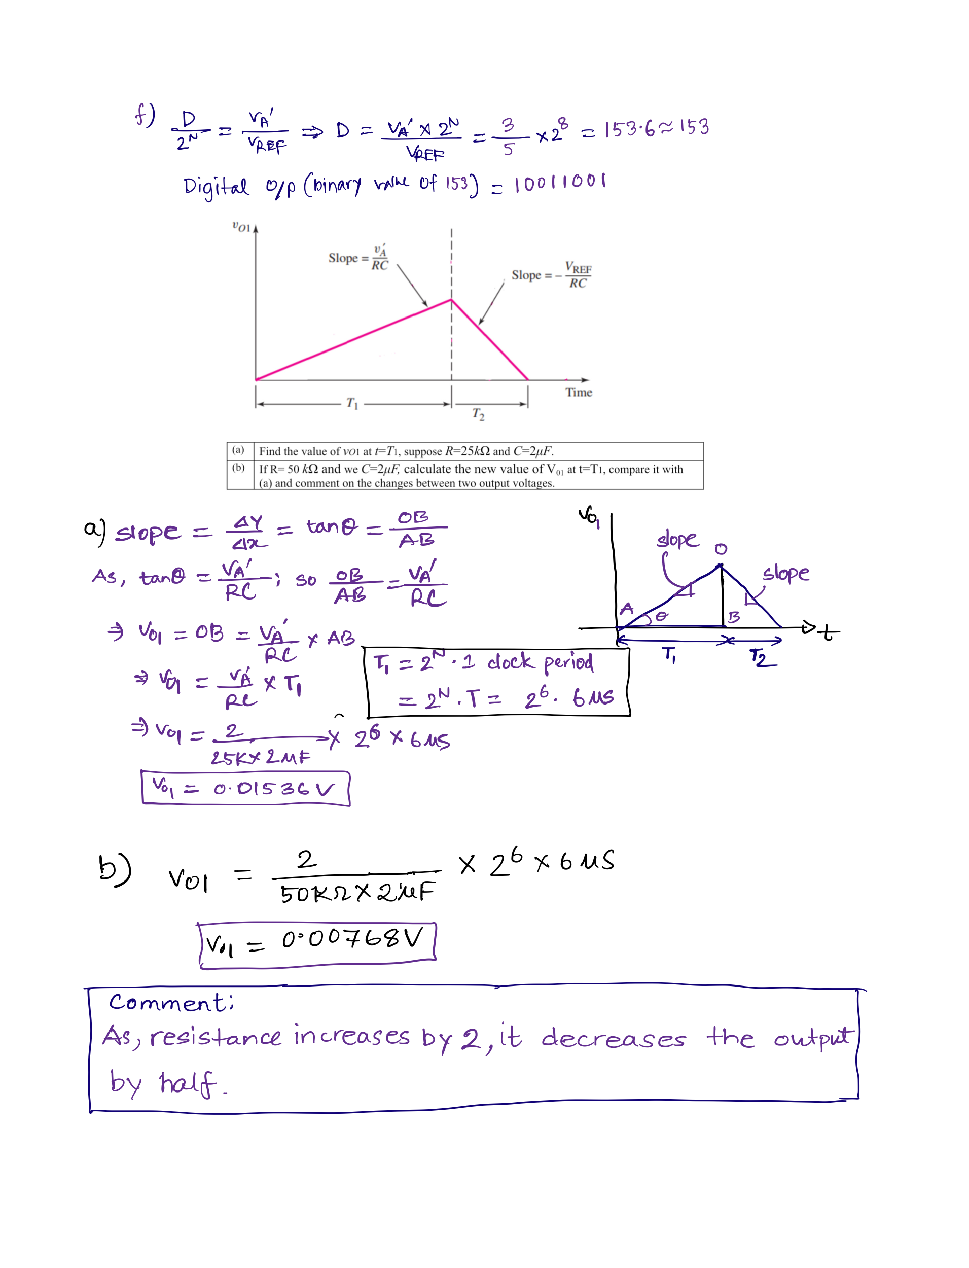

# 

# Question 5

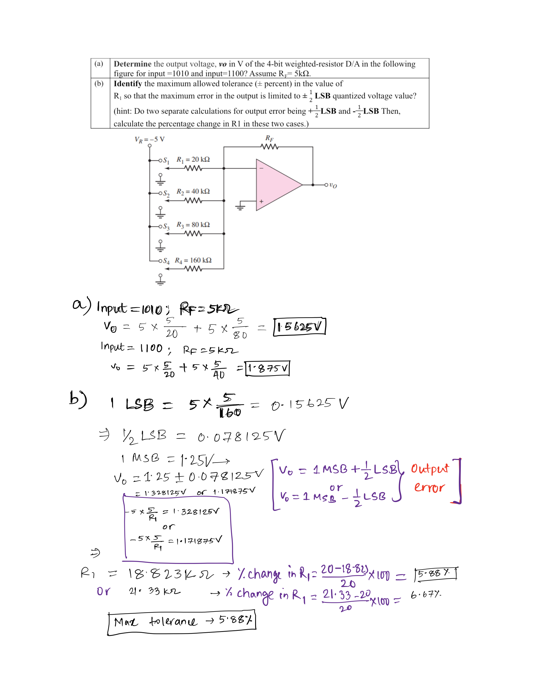

# 

# Question 6

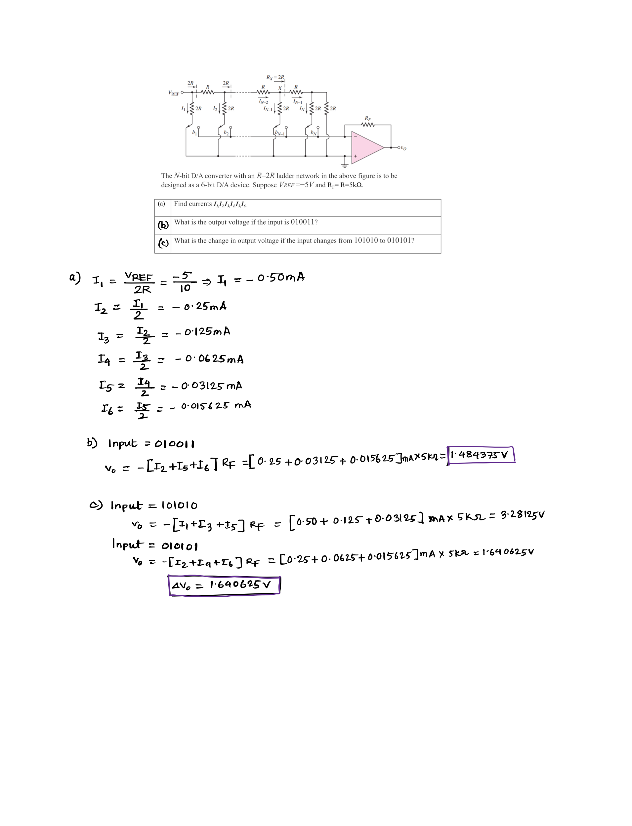

# 

# Question 7

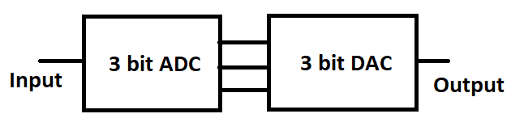

| ADC Input Voltage | Encoding | DAC Output Voltage |
| --- | --- | --- |
| 0-1 | 000 | 0.5 |
| 1-2 | 001 | 1.5 |
| 2-3 | 010 | 2.5 |
| 3-4 | 011 | 3.5 |
| 4-5 | 100 | 4.5 |
| 5-6 | 101 | 5.5 |
| 6-7 | 110 | 6.5 |
| 7-8 | 111 | 7.5 |

| (a) | For the following input waveshape, draw the reconstructed output by the DAC. The sampling instances are marked on the input waveshape. |
| --- | --- |
| (b) | Comment on the quality of the reconstructed signal and how the quality would be affected if additional bits were used for both the ADC and DAC. |



Solution:

